Exam

Name___________________________________

**MULTIPLE CHOICE. Choose the one alternative that best completes the statement or answers the question.**

**Provide an appropriate response.**

Given f(x + h) - f(x) = 4xh + 4h + 2h2, find the slope of the tangent line at x = 4.

|  |  |  |  |
| --- | --- | --- | --- |
| A) 8 | B) 20 | C) 22 | D) 16 |

**Find the average rate of change of the function over the given interval.**

y = x2+ 3x, [1, 7]

|  |  |  |  |
| --- | --- | --- | --- |
| A) 10 | B) 11 | C) | D) |

**Find the limit, if it exists.**

 

|  |  |  |  |
| --- | --- | --- | --- |
| A) -1 | B) Does not exist | C) 0 | D) 5 |

**Solve the problem.**

4) The graph shows the average cost of a barrel of crude oil for the years 1981 to 1990 in constant 1996 dollars. Find the approximate average change in price from 1981 to 1986.

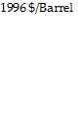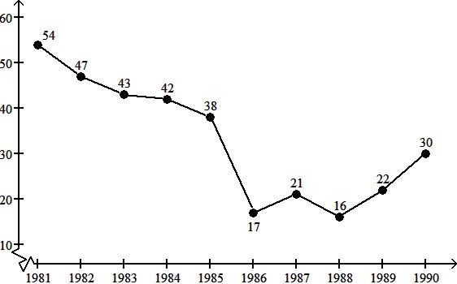

Year

4) _______

A) About -$7/year B) About -$4/year

C) About -$37/year D) About -$15/year

1) B

2) B

3) A

4) A