1) A scientist is hoping to compare the levels of DDT toxin found in three species of fish in a local river. He randomly samples 7 of each species to use in the analysis. For each fish, he measures the amount of DDT toxin present. The data is shown below:

Species

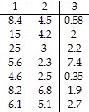

Ideally he will be able to determine if a difference exists in the population of DDT toxins found in the three fish species. Conduct the appropriate test and state the appropriate conclusion when testing at α = 0.025.

2) A medical researcher wishes to try three different techniques to lower blood pressure of patients with high blood pressure. The subjects are randomly selected and assigned to one of three groups. Group 1 is given medication, Group 2 is given an exercise program, and Group 3 is assigned a diet program. At the end of six weeks, the reduction in each subject's blood pressure is recorded. Use the appropriate statistical test to test the claim that there is no difference in the distribution of the populations. Use 

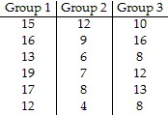

3) Four different types of fertilizers are used on raspberry plants. The number of raspberries on each randomly selected plant is given below. . Use the appropriate statistical test to test the claim that there is no difference in the distribution of the populations. Use 

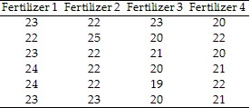

4) A researcher wishes to determine whether there is a difference in the average age of elementary school, high school, and community college teachers. Teachers are randomly selected. Their ages are recorded below. Use the appropriate statistical test to test the claim that there is no difference in the distribution of the populations. Use 

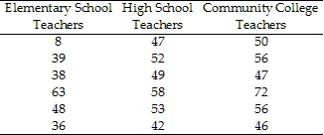

5) The grade point averages of students participating in sports at a college are to be compared. The data are listed below. . Use the appropriate statistical test to test the claim that there is no difference in the distribution of the populations. Use 

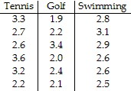

6) The time (in minutes) it takes to assemble a computer component for three different machines is listed below. Workers are randomly selected. Use the appropriate statistical test to test the claim that there is no difference in the distribution of the populations. Use 

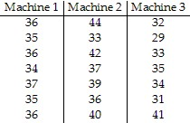

7) A realtor wishes to compare the square footage of houses in 4 different cities, all of which are priced approximately the same. The data are listed below . Use the appropriate statistical test to test the claim that there is no difference in the distribution of the populations. Use 

