Type: E
Title: Gallup Stress

1) According to Gallup, about 33% of Americans polled said they frequently experience stress in their daily lives. Suppose you are in a class of 45 students. a. What is the probability that no more than 12 students in the class will say that they frequently experience stress in their daily lives? (Make sure to identify the sampling distribution you use and check all necessary conditions.) b. If 20 students in the class said they frequently experience stress in their daily lives, would you be surprised? Explain, and use statistics to support your answer.

Type: E
Title: Electrical

2) It is generally believed that electrical problems affect about 14% of new cars. An automobile mechanic conducts diagnostic tests on 128 new cars on the lot. a. Describe the sampling distribution for the sample proportion by naming the model and telling its mean and standard deviation. Justify your answer. b. Sketch and clearly label the model. c. What is the probability that in this group over 18% of the new cars will be found to have electrical problems?

Type: E
Title: Near Sightedness

3) It is generally believed that nearsightedness affects about 12% of children. A school district gives vision tests to 133 incoming kindergarten children. a. Describe the sampling distribution model for the sample proportion by naming the model and telling its mean and standard deviation. Justify your answer. b. Sketch and clearly label the model. c. What is the probability that in this group over 15% of the children will be found to be nearsighted?

Type: E
Title: CDC

4) According to the Centers for Disease Control, about 36% of U.S. adults were obese in 2013. To see if that has changed since the last study, a random sample of 250 U.S. adults will be checked. a. Describe the sampling distribution model for the sample proportion (assuming no change in obesity rates) by naming the model and telling its mean and standard deviation. Justify your answer. b. Sketch and clearly label the model. c. What is the probability that in this group less than 25% of the adults will be found to be obese?

Answers:

- a. We want to find the probability that no more than 12 students in the class will say that they frequently experience stress. This is the same as asking the probability of finding less than 26.7% of "stressed" students in a class of 45 students. Check the conditions: 1. 10% condition: 45 students is less than 10% of all students who could take the class 2. Success/failure cond.: np = 45(0.33) = 14.85, nq = 45(0.67) = 30.15, which both exceed 10 We can use the N(0.33 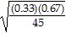 = 0.070) to model the sampling distribution. We need to standardize the 26.7% and then find the probability of getting a z-score less than or equal to the one we find: z = 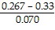 = -0.90 P( < 0.267) = P(z < -0.90) = 0.1841, so the probability is about 18.4% that no more than 12 students will say that they frequently experience stress in their daily lives. b. From part a, we can use N(0.33, 0.070) to model the sampling distribution. Twenty students is about 44.4% of the class. This is about 1.63 standard deviations above what we would expect, which is not a surprising result.

2) a. We can assume these cars are a representative sample of all new cars, and certainly less than 10% of them. We expect np = (128)(0.14)= 17.92 successes (electrical problems) and failures (no problems) so the sample is large enough to use the sampling model N(0.14, 0.031). SD() = = 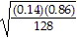 = 0.031 b. 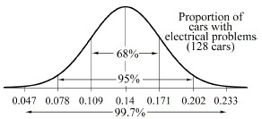 c. z = 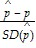 P( > 0.18) = P(z > 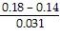) = P(z > 1.30) = 0.096, about 10%

3) a. We can assume these kids are a random sample of all children, and certainly less than 10% of them. We expect np = (133)(0.12) = 15.96 successes and 117.04 failures so the sample size is large enough to use the sampling model N(0.12, 0.028). b.
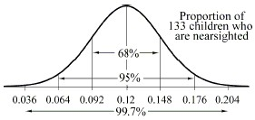 c. z = 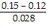 = 1.07 P( > 0.15) = P(z > 1.07) = 0.142

4) a. These adults are a random sample of all U.S. adults, and certainly less than 10% of them. We expect np = 250(0.36) = 90 successes and 160 failures so the sample size is large enough to use the sampling model N(0.36, 0.030). b. 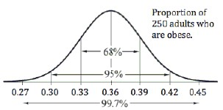c. z = 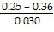 = -3.67 P( < 0.25) = P(z < -3.67) = 0.00012

